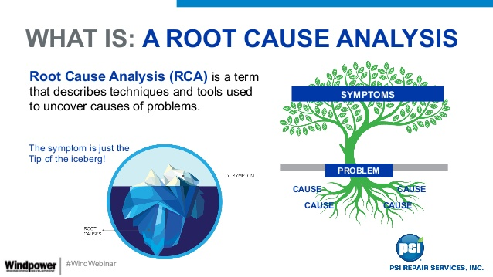

Impact Analysis (IA) – Used for the new and modified scope
- What is IA?
  - Impact Analysis is the approach and methodology used to critically analyze the changes from release/sprint to release/sprint by identifying the modules/sub-modules, libraries, databases, interfaces, integrations and others that are impacted and needing verification and validation – through categorization of High/Medium/Low

- When do we do this?
  - When there are changes and fixes made: To critically analyze the impact from changes and QE scope to be identified and covered during testing
- Benefits:
  - Covering tests that are very import for the verification and validation
  - Elimination of and not covering and executing tests that are not required to be covered
  - Saving time and effort from testing the right scope

Root Cause Analysis (RCA) – Used for the issues found by the customers predominately
- What is RCA?
  - Root Cause Analysis is performed for the issues originated from customers and missed in QE tests. This is the process of tracing the issues at module/sub-module/libraries/interfaces level to find what caused these issue and how did we miss them in QE tests

- When do we do this?
  - When issues found and needing to know what caused the issues leak to customers – to help us increase QE scope to cover these issues in testing

- Benefits:
  - To help identify the reasons for issues/bugs being leaked to customers
  - Helps in arriving at the pattern of issues generated and increases quality testing efficiency and productivity
  - Address customer quality and leading to customer happiness

IA and RCA initiatives are very critical and important for customer quality and need very high priority and attention

